 | Pimpri-Chinchwad Education Trust's  Pimpri-Chinchwad College of Engineering  (An Autonomous Institute)  Affiliated to Savitribai Phule Pune University (SPPU)  ISO 21001:2018 Certified by TUV
VSEC MINI PROJECT
DEPARTMENT OF INFORMATION TECHNOLOGY
PROJECT REPORT
SUBJECT: VSEC - DATA SCIENCE LABORATORY
PROJECT TITLE:
"MARKET BASKET ANALYSIS AND CUSTOMER PURCHASE BEHAVIOUR ON A GROCERY DATASET"
SUBMITTED BY:
Name | PRN
Madhura Dande | 125B1F233
UNDER THE GUIDANCE OF:
Jyoti Manoorkar Ma'am
DATE: ____________ SIGN: ______________
YEAR: SECOND YEAR
SEMESTER: III DIVISION: B BATCH: B4
ACADEMIC YEAR: 2026-27

ABSTRACT
Grocery stores collect a record of every purchase, but the raw records say very little until they are analysed. In this mini project we studied a grocery retail dataset of 38,765 item purchases made by 3,898 customers over two years (2014 and 2015). After cleaning the data, the purchases were grouped into 14,963 shopping baskets (one customer, one day) and examined with the Python data science stack: Pandas, NumPy, Matplotlib, Seaborn, SciPy and scikit-learn.
The work covers data cleaning, exploratory analysis, correlation and hypothesis testing, association rule mining (support, confidence and lift), classification, regression and customer segmentation using K-Means. The main results are: whole milk, other vegetables and rolls/buns together make up about 15.36% of all purchases; the average basket has only 2.5 items, so strong item-to-item associations are rare; the number of baskets fell by about 12.5% from 2014 to 2015; and daily sales volume is close to random, so models can improve only slightly over a simple average. Customers were grouped into three segments, and one of them (916 customers) has not visited the store for more than a year.
The report also discusses honestly where the models did not work well and why, and ends with practical suggestions for a store manager.
TABLE OF CONTENTS
Abstract 2
1. Introduction 3
2. Dataset and Data Preparation 4
3. Tools and Environment 6
4. Methodology 7
5. Exploratory Data Analysis 8
6. Statistical Analysis and Hypothesis Testing 11
7. Association Rule Mining 13
8. Machine Learning Models 15
9. Model Evaluation and Discussion 18
10. Findings and Recommendations 19
11. Conclusion and Future Scope 20
References 21
Appendix: Code Files 22

1. Introduction

1.1 Background
Every time a customer pays at a grocery store, the bill is saved as data. Over months and years this becomes a large collection of what people buy, when they buy it and how often they come back. Data science helps a shop owner turn this record into decisions: which products to stock more of, which products to place close together, and which customers need attention.
One of the best-known techniques for this kind of data is Market Basket Analysis. It looks at the items that are bought together in the same visit and tries to find patterns such as "customers who buy A also tend to buy B". The same data can also be used for ordinary data science tasks like trend analysis, prediction and customer grouping.

1.2 Problem Statement
A grocery retailer has two years of transaction records but no simple way to understand customer buying behaviour from them. The task is to clean the records, explore them, test a few common assumptions statistically, find products that are bought together, and build basic models to predict purchases and sales. The results should be easy to read for a non-technical shop owner.

1.3 Objectives
- To load, clean and prepare the grocery transaction data using Pandas.
- To explore the data with summary statistics and graphs (Matplotlib and Seaborn).
- To study relationships between items and test hypotheses about customer behaviour using SciPy.
- To find frequently bought item pairs using support, confidence and lift.
- To build and compare classification and regression models with scikit-learn, and to group customers using K-Means.
- To summarise the findings as practical suggestions for the store.

1.4 Scope
The project uses a single public grocery dataset. It does not contain prices, quantities or product categories, so the analysis is about what was bought and when, not how much money was spent. Association rules are limited to pairs of items because baskets are small. These limits are discussed again in the last chapter.

2. Dataset and Data Preparation

2.1 Dataset Description
The dataset (Groceries_dataset.csv) is a transaction log from a grocery store. Each row is one item bought by one customer on one date. It has three columns:
Column | Meaning | Type
Member_number | ID of the customer (loyalty member) | Integer
Date | Date of purchase (dd-mm-yyyy) | Text, converted to date
itemDescription | Name of the item bought | Text
Table 2.1: Columns of the dataset
Property | Before cleaning | After cleaning
Rows (item purchases) | 38,765 | 38,006
Customers | 3,898 | 3,898
Different items | 167 | 167
Period covered | - | 2014-01-01 to 2015-12-30
Missing values | 0 | 0
Duplicate rows | 759 | 0
Baskets (customer + day) | - | 14,963
Table 2.2: Dataset at a glance

2.2 Data Cleaning
The following steps were carried out before any analysis:
- Date conversion: the Date column was stored as text, so it was converted to a proper datetime type using the format dd-mm-yyyy. This allows us to extract month, year and weekday.
- Text standardisation: item names were stripped of extra spaces and converted to lower case so that the same product is never counted under two spellings.
- Missing values: a check showed there are no missing values in any column, so nothing had to be filled or removed.
- Duplicates: 759 rows were exact copies (same customer, same date, same item). For basket analysis only the presence of an item matters, so these were dropped, leaving 38,006 rows.
- Creating baskets: the dataset has no bill number, so all items bought by one customer on one date were treated as one basket. This gave 14,963 baskets.
df = pd.read_csv("Groceries_dataset.csv")
df["Date"] = pd.to_datetime(df["Date"], format="%d-%m-%Y")
df["itemDescription"] = df["itemDescription"].str.strip().str.lower()
print(df.isnull().sum().sum()) # 0 missing values
print(df.duplicated().sum()) # 759 duplicate rows
df = df.drop_duplicates().reset_index(drop=True)

# one basket = one member on one date
df["basket"] = df.groupby(["member", "date"]).ngroup()

2.3 Derived Columns
From the date we created month, year, weekday and a weekend flag (Saturday and Sunday = 1). From the basket we created the basket size (number of different items). These columns are used later in the EDA, the hypothesis tests and the machine learning models.

3. Tools and Environment
The whole project was written in Python and run in a Jupyter Notebook / VS Code environment, which are the tools introduced in the first unit of the laboratory course. The libraries used are listed below.
Tool / Library | Used for
Python 3 | Main programming language
Jupyter Notebook, VS Code | Writing and running code step by step
Pandas | Loading the CSV, cleaning, grouping and aggregation
NumPy | Numerical operations and arrays
Matplotlib | Basic charts (bar, line, scatter)
Seaborn | Heatmap, count plots and styled charts
SciPy (stats) | Pearson correlation, t-test, chi-square test, ANOVA
scikit-learn | Train/test split, models, evaluation metrics, K-Means
Table 3.1: Tools and libraries
No special hardware was needed. The complete analysis runs in less than a minute on a normal laptop because the dataset is small (about 38 thousand rows).

4. Methodology
The project followed the usual data science workflow. Each step is matched with the unit of the laboratory syllabus that it belongs to.
Step | What was done | Syllabus unit
1. Data acquisition | Loaded the CSV file into a Pandas DataFrame | Data Acquisition and Cleaning
2. Cleaning | Fixed dates and text, removed duplicates, built baskets | Data Acquisition and Cleaning
3. EDA | Summary statistics and graphs of items, time, baskets, customers | Visualization and EDA
4. Statistics | Correlation and four hypothesis tests | Statistical Data Modeling
5. Association rules | Support, confidence and lift for item pairs | Algorithmic Data Modeling
6. Machine learning | Classification, regression and clustering | Algorithmic Data Modeling
7. Evaluation | Accuracy, precision, recall, F1, AUC, MAE, RMSE, R2 | Model evaluation
8. Reporting | Findings and recommendations | Mini-project and presentation
Table 4.1: Project workflow
Train/test split. For the classification model 80% of the baskets were used for training and 20% for testing, keeping the same share of milk baskets in both parts (stratified split). For the regression model the data is a time series, so the first 80% of the days were used for training and the last 20% for testing, because we should never train on the future.

5. Exploratory Data Analysis
EDA was done to understand what the data looks like before applying any model.

5.1 Basic Summary
Measure | Value
Total baskets | 14,963
Average basket size | 2.54 items
Median / most common basket size | 2 / 2 items
Largest basket | 10 items
Average visits per customer (2 years) | 3.84
Most visits by one customer | 11
Items bought fewer than 20 times | 26 of 167
Table 5.1: Summary statistics

5.2 Most Popular Items
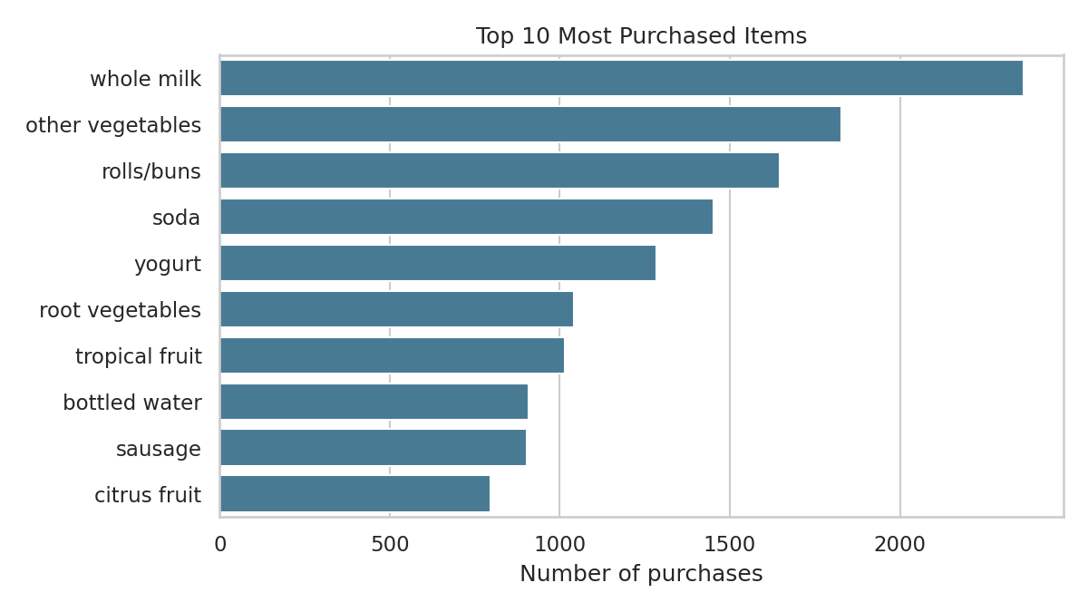
Figure 5.1: Ten most purchased items
Whole milk is the most popular item with 2,363 purchases (6.2% of all purchases), followed by other vegetables (1,827) and rolls/buns (1,646). The top three items together account for 15.36% of all purchases and the top ten account for 34.82%. So the store depends heavily on a small group of everyday products, while many of the 167 items are bought only a few times (for example kitchen utensils and preservation products were bought once).

5.3 Sales over Time
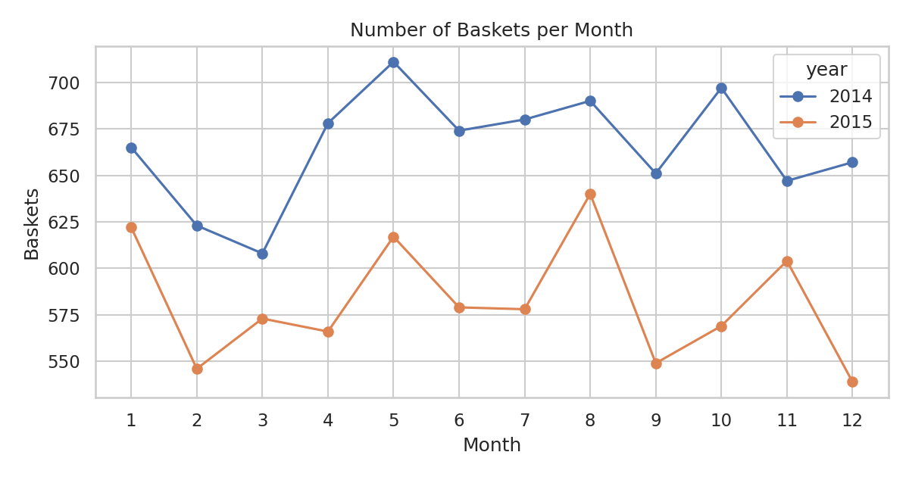
Figure 5.2: Baskets per month in 2014 and 2015
The monthly number of baskets stays fairly steady inside each year, with no strong seasonal peak. The highest month is May 2014 (711 baskets) and the lowest is December 2015 (539). The more noticeable change is between the two years: 2014 had 7,981 baskets while 2015 had 6,982, a drop of about 12.5%. Every single month of 2015 is below the same month of 2014, which shows that the fall is general and not caused by one bad month.
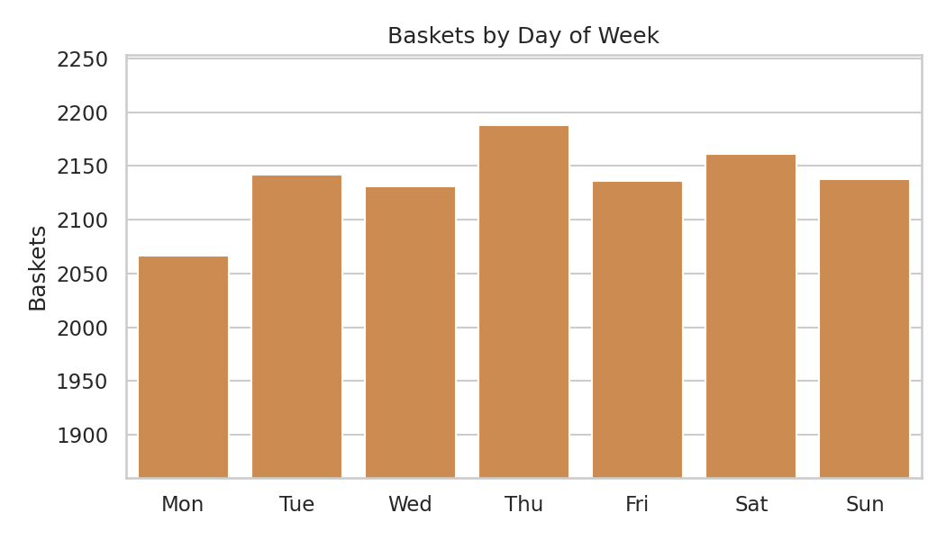
Figure 5.3: Baskets by day of the week
Customers shop on all seven days almost equally. Monday is slightly lower (2,067 baskets) and Thursday is slightly higher (2,188), but the difference is small. This means the store does not have a clear busy day.

5.4 Basket Size and Customer Visits
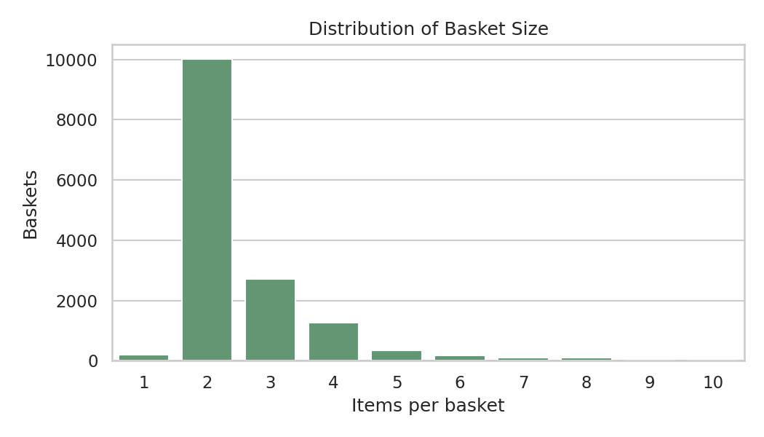
Figure 5.4: Distribution of basket size
Most baskets are small. About 86.5% of baskets contain three items or fewer and only 5% contain five or more items. This is an important fact for the later chapters: when a basket has only two or three items, it is hard for two particular items to appear together often.
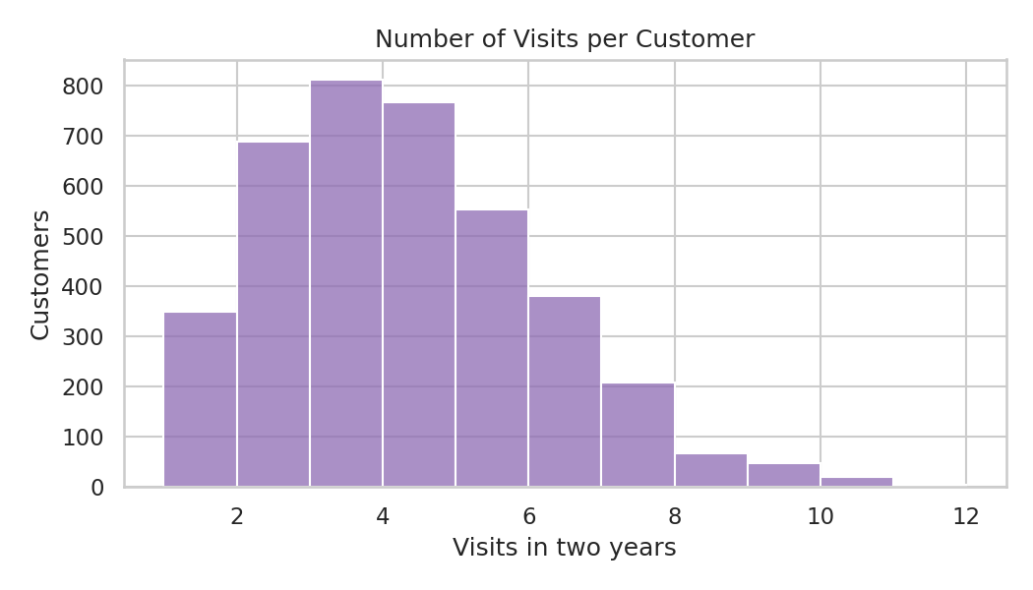
Figure 5.5: Number of visits per customer
A typical customer made about 4 visits in two years (mean 3.84, median 4). A few customers came 10 or 11 times, so the store has a small group of regular buyers and a larger group of occasional ones.

6. Statistical Analysis and Hypothesis Testing

6.1 Correlation Analysis
Correlation tells us whether two things move together. Here we checked whether the top eight items tend to appear in the same basket. For every basket, each item was marked 1 (present) or 0 (absent) and the Pearson correlation coefficient (r) was calculated for every pair. The value of r lies between -1 and +1, where 0 means no linear relationship.
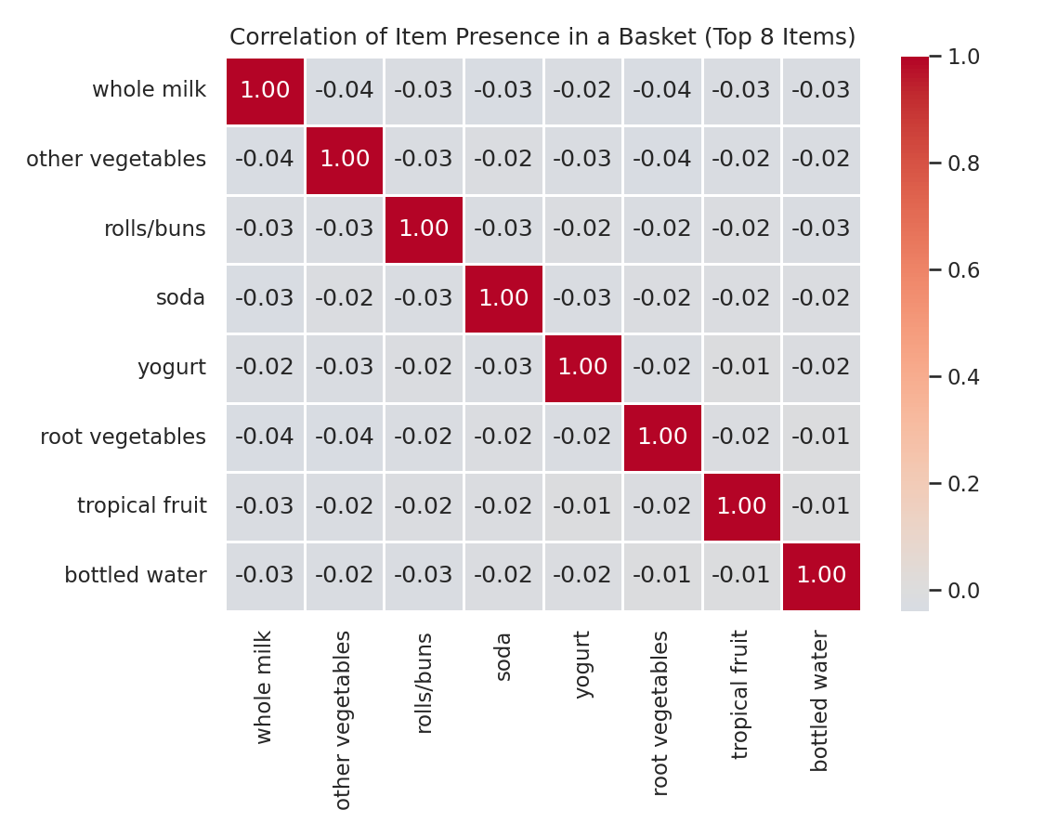
Figure 6.1: Correlation heatmap of the top eight items
All the correlations are very small and slightly negative (from -0.039 to -0.009). This means that buying one popular item makes it very slightly less likely that another popular item is in the same basket. The reason is the small basket size: if a basket has only two items and one is milk, there is little room left for the others. So in this data the popular products behave almost independently of each other.
We also compared the monthly basket counts of 2014 and 2015. The correlation is r = 0.451 with p = 0.1411. This is a moderate positive value, but since p is more than 0.05 we cannot say it is statistically significant (there are only 12 months).

6.2 Hypothesis Testing
Hypothesis testing checks a claim using sample data. We state a null hypothesis (H0, "nothing is happening") and an alternative hypothesis (Ha). If the p-value is less than the significance level 0.05, H0 is rejected. Four tests were performed.
Test 1: Do weekend baskets differ in size from weekday baskets? (Welch t-test)
- H0: the mean basket size on weekends is equal to that on weekdays. Ha: they are different.
- Result: weekend mean = 2.527 items (n = 4,299), weekday mean = 2.545 items (n = 10,664); t = -0.951, p = 0.342.
- Decision: p > 0.05, so we fail to reject H0. People do not buy more items on weekends.
Test 2: Are whole milk and other vegetables bought independently? (Chi-square test)
- H0: buying whole milk and buying other vegetables are independent. Ha: they are related.
 | No vegetables | Vegetables | Total
No milk | 10,995 | 1,605 | 12,600
Milk | 2,141 | 222 | 2,363
Table 6.1: Contingency table of milk and vegetables (baskets)
- Result: chi-square = 20.44, degrees of freedom = 1, p = 6.16e-6.
- Decision: p < 0.05, so we reject H0. The two items are statistically related. If they were independent we would expect about 289 baskets with both, but we observe only 222, so the relationship is negative: customers who buy milk are less likely to buy vegetables in the same visit.
Test 3: Does basket size change from month to month? (One-way ANOVA)
- H0: the mean basket size is the same in all 12 months. Ha: at least one month is different.
- Result: F = 1.421, p = 0.1557.
- Decision: p > 0.05, so we fail to reject H0. There is no evidence of seasonal change in basket size.
Test 4: Is the average basket size the same in 2014 and 2015? (Welch t-test)
- H0: mean basket size in 2014 equals that in 2015. Ha: they are different.
- Result: mean 2014 = 2.26, mean 2015 = 2.86; t = -34.541, p < 0.001.
- Decision: reject H0. Baskets in 2015 were larger (2.86 items) than in 2014 (2.26 items), even though there were fewer baskets. The data does not tell us the reason; it could be a real change in shopping habits (fewer, bigger trips) or a change in how the records were collected.
Test | Method | p-value | Decision
1. Weekend vs weekday basket size | Welch t-test | 0.342 | Fail to reject H0
2. Milk vs vegetables | Chi-square | < 0.001 | Reject H0
3. Basket size across months | ANOVA | 0.156 | Fail to reject H0
4. Basket size 2014 vs 2015 | Welch t-test | < 0.001 | Reject H0
Table 6.2: Summary of hypothesis tests (alpha = 0.05)
from scipy import stats
a = baskets.loc[baskets.weekend == 1, "size"]
b = baskets.loc[baskets.weekend == 0, "size"]
t, p = stats.ttest_ind(a, b, equal_var=False) # Welch t-test

ct = pd.crosstab(has_milk, has_veg)
chi2, p, dof, expected = stats.chi2_contingency(ct) # chi-square test

7. Association Rule Mining

7.1 Concept
Association rule mining finds items that are bought together. A rule is written as A -> B, which means "baskets that contain A also contain B". Three measures are used to judge a rule:
- Support: how often the items appear together in all baskets. Support(A,B) = baskets with A and B / total baskets.
- Confidence: how often B is bought when A is bought. Confidence(A->B) = baskets with A and B / baskets with A.
- Lift: how much more (or less) likely B becomes when A is present, compared with B's normal popularity. Lift = Confidence(A->B) / Support(B).
A lift above 1 means the items are bought together more than expected by chance, a lift of 1 means they are independent and a lift below 1 means they are bought together less than expected.

7.2 Method
Every basket was converted into a set of items. All pairs of items inside each basket were counted (6,260 different pairs were found). Pairs that appeared in at least 0.25% of baskets (about 37 baskets) were kept, which gave 286 rules (each pair gives two rules, one in each direction). Because most baskets have only two or three items, larger item sets were not mined. The Apriori idea (keep only frequent items) was applied by writing the counting logic ourselves in Python.
from itertools import combinations
from collections import Counter
single, pair = Counter(), Counter()
for items in baskets["items"]:
s = sorted(set(items))
single.update(s)
pair.update(combinations(s, 2))

for (x, y), count in pair.items():
support = count / n_baskets
if support >= 0.0025:
confidence = count / single[x]
lift = confidence / (single[y] / n_baskets)

7.3 Results
Rule | Support | Confidence | Lift
sausage -> curd | 0.29% | 4.9% | 1.45
curd -> sausage | 0.29% | 8.7% | 1.45
sausage -> bottled beer | 0.33% | 5.5% | 1.22
bottled beer -> sausage | 0.33% | 7.4% | 1.22
other vegetables -> frankfurter | 0.51% | 4.2% | 1.12
frankfurter -> other vegetables | 0.51% | 13.6% | 1.12
Table 7.1: Rules with the highest lift
Rule | Support | Confidence | Lift
whole milk -> other vegetables | 1.48% | 9.4% | 0.77
rolls/buns -> whole milk | 1.40% | 12.7% | 0.80
soda -> whole milk | 1.16% | 12.0% | 0.76
yogurt -> whole milk | 1.12% | 13.0% | 0.82
rolls/buns -> other vegetables | 1.06% | 9.6% | 0.79
other vegetables -> soda | 0.97% | 7.9% | 0.82
Table 7.2: Rules with the highest support
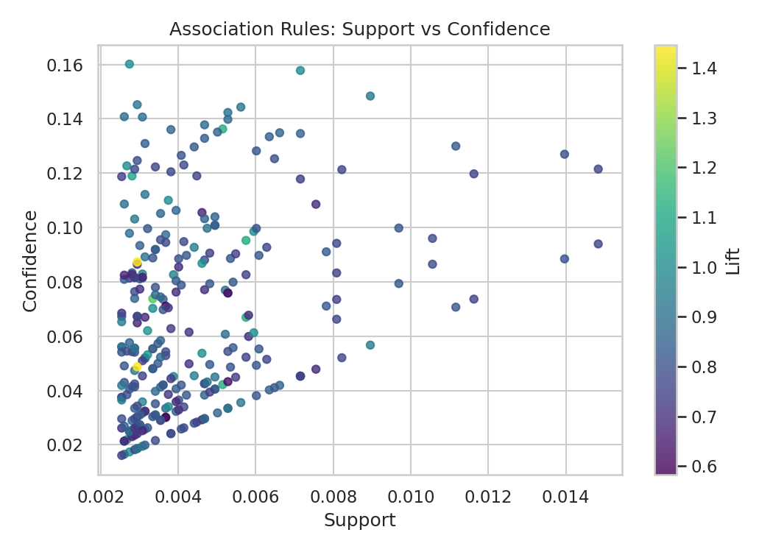
Figure 7.1: Support vs confidence of all rules (colour = lift)

7.4 Interpretation
- Only 24 of the 286 rules (about 8%) have a lift above 1. The strongest is sausage and curd with lift 1.45, but it comes from only about 44 baskets, so it is a weak signal.
- The most frequent pairs (for example rolls/buns and whole milk) have a lift below 1. They appear together often only because both items are very popular on their own, not because customers link them.
- Sausage appears in several of the positive rules (with curd, bottled beer and yogurt), so it is the item most worth experimenting with for combo offers.
- Overall, strong associations are missing in this dataset. This agrees with the correlation results of Chapter 6 and is explained by the small basket size.

8. Machine Learning Models

8.1 Classification: Will the Basket Contain Whole Milk?
Whole milk is the most common item and appears in 15.8% of baskets. We tried to predict whether a basket contains whole milk using the other items in the basket. The features were: presence (0/1) of the 30 next most popular items, the month and the weekday. Three models were trained: Logistic Regression, Decision Tree (depth 5) and Random Forest (200 trees, depth 8). Class weights were set to "balanced" because milk baskets are the minority class.
Model | Accuracy | Precision | Recall | F1 | ROC-AUC
Baseline (always No) | 0.842 | 0.000 | 0.000 | 0.000 | 0.500
Logistic Regression | 0.550 | 0.201 | 0.619 | 0.303 | 0.601
Decision Tree | 0.431 | 0.170 | 0.670 | 0.271 | 0.531
Random Forest | 0.591 | 0.197 | 0.518 | 0.286 | 0.586
Table 8.1: Classification results on the test set
The result is not strong, and it is important to read it correctly. A dummy model that always says "no milk" already gets 0.842 accuracy, because only about 16% of baskets contain milk. The three real models have lower accuracy than this dummy model, but they do find milk baskets (recall of 52% to 67%) which the dummy never does. Precision stays near 0.2, which is close to the 16% base rate, and the best AUC is only 0.60 (Logistic Regression) against 0.5 for random guessing. So the other items in a basket tell us very little about whether milk is there.
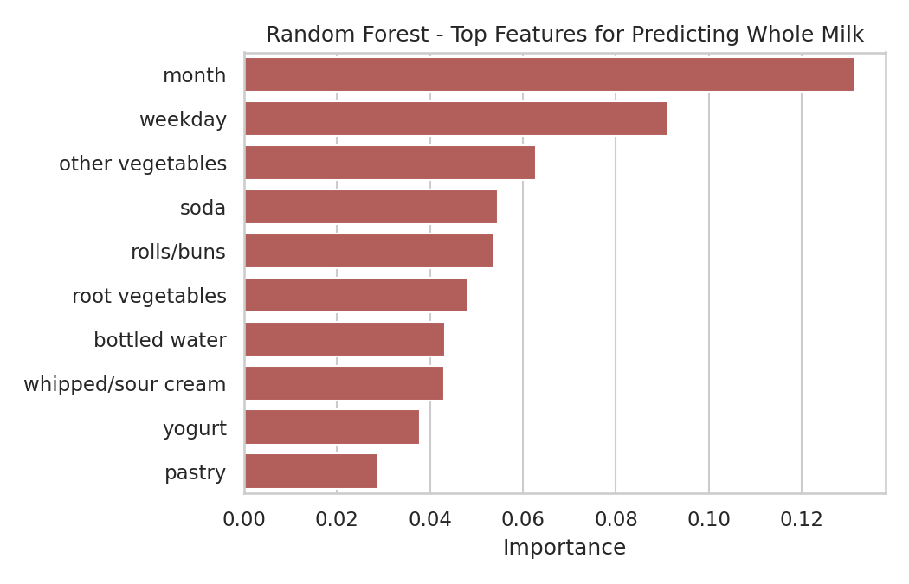
Figure 8.1: Feature importance in the Random Forest
The feature importance chart shows that no single product is a strong predictor; month and weekday come out highest, but even they carry only a small share, and the popular items are all close to each other, which looks like noise rather than a real pattern. This matches the lift values below 1 from the previous chapter: milk is a staple that customers buy on its own or with anything, so it cannot be predicted from the rest of the basket.
X_train, X_test, y_train, y_test = train_test_split(
X, y, test_size=0.2, random_state=42, stratify=y)
rf = RandomForestClassifier(n_estimators=200, max_depth=8,
class_weight="balanced", random_state=42)
rf.fit(X_train, y_train)
pred = rf.predict(X_test)
print(accuracy_score(y_test, pred), f1_score(y_test, pred))

8.2 Regression: Predicting Baskets per Day
For regression we predicted the number of baskets on a day. The features were the number of baskets one day ago (lag 1), seven days ago (lag 7), the average of the previous seven days and a day counter. The first 80% of the days (578 days) were used for training and the last 20% (145 days) for testing. The average day has 20.48 baskets with a standard deviation of 4.86.
Model | MAE | RMSE | R2
Baseline (training mean) | 3.76 | 4.93 | -0.222
Linear Regression | 3.44 | 4.41 | 0.023
Random Forest Regressor | 3.70 | 4.82 | -0.170
Table 8.2: Regression results on the test period
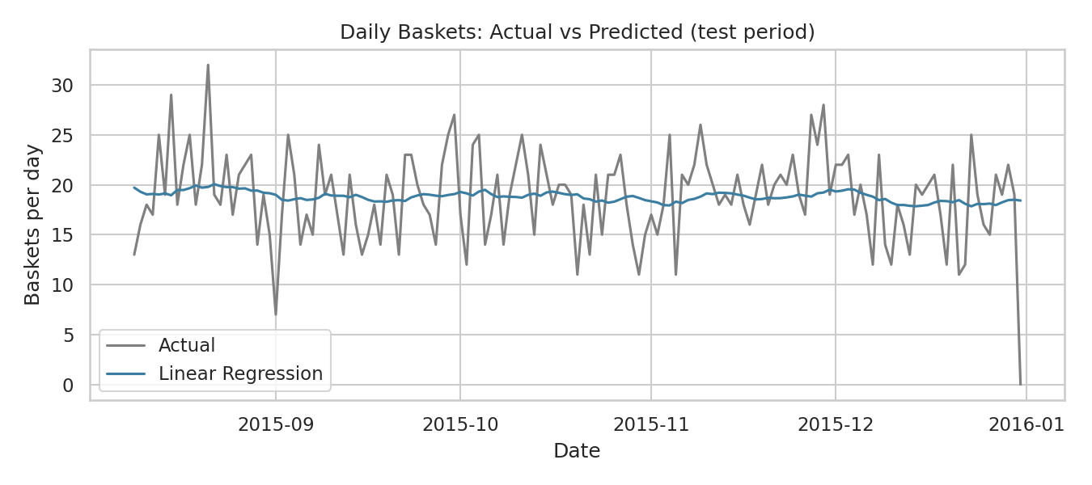
Figure 8.2: Actual and predicted baskets per day (test period)
Linear Regression is the best of the three: its error (MAE 3.44 baskets) is lower than the baseline (3.76), but R2 is only 0.023, which means almost none of the day-to-day variation is explained. The Random Forest did worse than the simple average, a sign of over-fitting to noise. The baseline itself has a negative R2 because the test period (late 2015) is quieter than the training period, so the training average is too high. The conclusion is that daily footfall in this store is mostly random, and a manager should plan with an average of about 20 baskets a day and a safety margin of around 5.

8.3 Clustering: Customer Segments with K-Means
To understand customers we calculated three values for each one: number of visits, total items bought and recency (days since the last visit, counted up to 30 December 2015). The values were standardised and K-Means clustering was applied. The elbow method (Figure 8.3) shows the curve bending around k = 3, so three clusters were used.
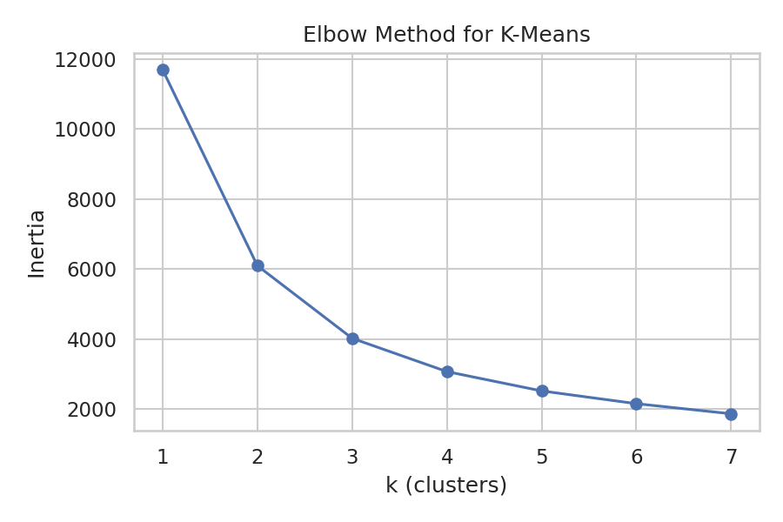
Figure 8.3: Elbow curve for K-Means
Segment | Customers | Avg visits | Avg items | Avg days since last visit
Loyal regulars | 1,251 | 6 | 15.7 | 109.2
Occasional shoppers | 1,731 | 3.1 | 7.9 | 121.7
Lapsed customers | 916 | 2.2 | 5.2 | 419.7
Table 8.3: Customer segments
The loyal regulars (1,251 customers) visit about six times and buy nearly 16 items in two years. The occasional shoppers (1,731) are the biggest group. The lapsed customers (916) have made only about two visits and have not returned for more than a year on average, so they are the group the store is most likely to have lost.

9. Model Evaluation and Discussion

9.1 Metrics Used
Metric | Meaning | Used for
Accuracy | Share of all predictions that are correct | Classification
Precision | Of the baskets predicted as "milk", how many really had milk | Classification
Recall | Of the baskets that really had milk, how many were found | Classification
F1-score | Balance of precision and recall | Classification
ROC-AUC | Ability to separate the two classes (0.5 = random, 1 = perfect) | Classification
MAE / RMSE | Average prediction error (RMSE punishes large errors more) | Regression
R2 | Share of variation explained (can be negative) | Regression
Inertia | Compactness of clusters (used for the elbow method) | Clustering
Table 9.1: Evaluation metrics

9.2 Comparison of Results
Task | Best model | Key result | Verdict
Classification (milk in basket) | Logistic Regression (by AUC) | AUC 0.60 | Weak
Regression (baskets per day) | Linear Regression | R2 0.023, MAE 3.44 | Very weak
Association rules | Sausage -> curd | Lift 1.45, support 0.29% | Weak but usable
Clustering (customers) | K-Means, k = 3 | Three clear segments | Useful
Table 9.2: Summary of tasks

9.3 Discussion
- Good scores are not guaranteed in data science. A model can only learn what is present in the data. Here the features (other items, calendar) hold little information about the target, so the models stay close to the baseline.
- Accuracy alone can mislead on imbalanced data. The "always no" model has 84% accuracy but is useless, which is why precision, recall and AUC were reported.
- Simple models are not always worse. The Random Forest was not better than Logistic Regression in AUC and was worse than Linear Regression on the daily forecast.
- The unsupervised part (clustering) gave the most useful business result, because customer behaviour differs clearly even when individual purchases are hard to predict.
- Reporting weak results honestly is part of a correct analysis. It tells the store not to invest in a complicated recommendation engine based on this data alone.

10. Findings and Recommendations

10.1 Key Findings
- A few staple products (whole milk, other vegetables, rolls/buns) make up 15.36% of purchases.
- Baskets are small (average 2.5 items), so most items are bought almost independently.
- Shopping is spread evenly across weekdays, weekends and months; there is no strong seasonal or weekly peak.
- The number of baskets dropped by about 12.5% in 2015, but the average basket became larger.
- Milk and vegetables are bought together less often than chance would suggest.
- Sausage has the highest lift with curd, bottled beer and yogurt, but support is low.
- About 916 customers (23.5%) look lapsed.

10.2 Recommendations for the Store
- Keep staples always in stock. Running out of milk, vegetables or bread affects the largest part of sales.
- Place complementary items near each other on a trial basis. Sausage with curd, beer or yogurt can be tested as a combo offer; the effect should be measured, since the evidence is weak.
- Run a win-back campaign. Send offers to the lapsed segment and reward the loyal regulars to keep them.
- Plan staff and stock on averages. With about 20 baskets a day and little weekly pattern, a fixed daily plan with a buffer is enough.
- Investigate the 2015 drop. Find out whether it comes from fewer customers, more competition or a change in data recording.

11. Conclusion and Future Scope

11.1 Conclusion
In this mini project a grocery transaction dataset of 38,765 rows was cleaned, grouped into 14,963 baskets and analysed using the Python data science tools taught in the Data Science Laboratory. Exploratory analysis showed a store that depends on a few staple products, with small baskets and steady sales. Statistical tests confirmed that milk and vegetables are negatively associated, that weekends and months make no difference to basket size, and that 2015 baskets were larger than 2014 ones. Association rule mining found only weak rules, and the classification and regression models stayed close to simple baselines. Customer segmentation using K-Means gave the clearest practical result by separating loyal, occasional and lapsed customers.
The project met its objectives and also showed that careful evaluation matters as much as building the model.

11.2 Limitations
- The dataset has no prices, quantities, product categories or bill numbers, so baskets had to be approximated by customer and date.
- Only two years of data from one store are available.
- Association rules were limited to pairs of items.
- Only customers with a loyalty number are recorded.

11.3 Future Scope
- Use item categories and prices to analyse revenue and profit, not just counts.
- Mine larger item sets with the full Apriori or FP-Growth algorithms.
- Build a recommender system using customer history.
- Use real time-series models such as ARIMA or Prophet for sales forecasting.
- Create a small Streamlit dashboard so that the store manager can explore the results.

References
- Grocery dataset: "Groceries_dataset.csv" (public market-basket dataset, 2014-2015), used as provided for this mini project.
- Joel Grus, Data Science from Scratch, O'Reilly Media.
- Wes McKinney, Python for Data Analysis, O'Reilly Media.
- Agrawal, R. and Srikant, R. (1994). Fast Algorithms for Mining Association Rules. VLDB Conference.
- Pandas documentation: https://pandas.pydata.org/docs/
- Matplotlib documentation: https://matplotlib.org/stable/
- Seaborn documentation: https://seaborn.pydata.org/
- SciPy stats documentation: https://docs.scipy.org/doc/scipy/reference/stats.html
- scikit-learn documentation: https://scikit-learn.org/stable/
- NPTEL course on Data Science: https://onlinecourses.nptel.ac.in/noc22_cs32/

Appendix: Code Files
The complete code is in a single Python script that reads the dataset, performs every step of this report and saves the graphs.
File | Description
Groceries_dataset.csv | Input dataset
grocery_analysis.py | Complete analysis code (cleaning, EDA, statistics, rules, ML, clustering)
association_rules.csv | All 286 rules with support, confidence and lift
results.json | All numeric results used in this report
figs/ | All graphs used in this report
Table A.1: Project files
To run the project: place Groceries_dataset.csv in the same folder as the script, install the libraries with "pip install pandas numpy matplotlib seaborn scipy scikit-learn" and run "python grocery_analysis.py".

